The Difference Between Showing vs. Telling

When you tell rather than show, you simply inform your reader of information rather than layering meaning. Sometimes concrete details are necessary to tell, other times you can develop depth by implying meaning.

You’re supplying information by simply stating it. You might report that a [character](https://jerryjenkins.com/character-development/) is “tall,” or “angry,” or “cold,” or “tired.”

That’s telling.

Showing would paint a picture the reader could see in her mind’s eye.

If your character is tall, your reader can deduce that because you mention others looking up when they talk with him. Or he has to duck to get through a door. Or when posing for a photo, he has to bend his knees to keep his head in proximity of others.

Rather than telling that your character is angry, show it by describing his face flushing, his throat tightening, his voice rising, his slamming a fist on the table.

Show, Don’t Tell Examples

Telling: When they embraced she could tell he had been smoking and was scared.

Showing: When she wrapped her arms around him, the sweet staleness of tobacco enveloped her, and he was shivering.

Telling: The temperature fell and the ice reflected the sun.

Showing: Bill’s nose burned in the frigid air, and he squinted against the sun reflecting off the street.

Telling: Suzie was blind.

Showing: Suzie felt for the bench with a white cane.

Telling: It was late fall.

Showing: Leaves crunched beneath his feet.

Telling: She was a plumber and asked where the bathroom was.

Showing: She wore coveralls carried a plunger and metal toolbox, and wrenches of various sizes hung from a leather belt around her waist. “Point me to the loo,” she said.

Telling: I had a great conversation with Tim over dinner and loved hearing his stories.

Showing: I barely touched my food, riveted by Tim. “Let me tell you another story,” he said.

Complete the following table, showing the emotions and situation outlined in the first column.

1. Find synonyms for the underlined words
2. Write an example without using any of the words in the 'show' column in your example

|  |  |  |
| --- | --- | --- |
| ***Show*** | ***Synonyms*** | ***Example*** |
| Humility about achievement | unassuming, modest, reserved | When I arrive at the 'Always Sunday' café for our interview, Dani Harati is sipping water, comfortably dressed in a loose white tee and jeans. I don't think I expected her to have trophies or medals, but surely a Nobel Prize Winner and developer of the COVID-19 vaccine would be at least wearing a power suit and Rolex.    It's a Saturday morning and I'm sure she'd rather be running one of the local river paths, a hobby she mentioned in her acceptance speech. Instead, she seems genuinely happy to talk to me, asking first about how I came to be a journalist.    Dani addresses the waiter by name. As we leave the café after our meal, she reaches down to pat the black poodle under the table at the door, exchanging a brief compliment with the poodle's owner. |
| Fear of being watched, overheard | Paranoia, apprehensive | Tim kept looking over his shoulder whilst talking to Isaac, his pupils dilated, palms sweaty and heart rate high. He saw shadows and heard voices. Without saying anything to Isaac, he got up and briskly walked to the bathroom. |
| Frustrated with being interrupted | Anger, exasperation | John was refocusing on his story, trying to get into the mindset he had the hour previously. He looked up at his whiteboard intently in deep thought, the whiteboard that he frequently gazed at whenever he looks for inspiration. A voice calls to him from downstairs to do some chores.  He clenches his fists and stomps down the stairs. He grabs his knife and gets ready to stab his father. |
| Tired from physical labour |  |  |
| Regretful but resilient |  |  |
| Passionate about a cause |  |  |
| Disgusted by irresponsibility |  |  |
| Energized by a place |  |  |
| A dark night |  |  |
| A crowded city street | Crammed, packed | Oliver had just got off the bus from the airport. This was it. He was now in New York, and it was all he imagined the experience to be like and more.  What immediately struck him was the beauty of the metropolitan area. There were so many brilliant colours that his eyes had to adjust to, a stark contrast from the bland, barren deserts from his motherland.  The fragrance from the restaurants filled his nose and his stomach immediately rumbled. He didn’t realise that food could smell like that. After he had taken a few minutes to take in all the beauty, what immediately struck him next was the bustling streets filled to the brim with people. He closed his eyes and took a deep breath, and then took a step forward, merging like a drop of water falling into a raging river. |
| A loud party |  |  |

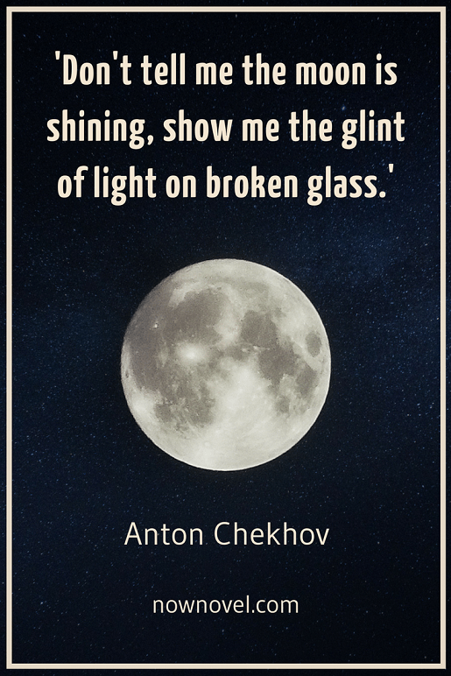**Student example of telling**: *Her room was filled with everything a teenage girl would ever need. Her closet was stuffed full of designer clothes…Even with all this stuff she wasn’t happy.*

**My rewriting to ‘show’**: The lifeless dresses hung like deflated balloons in her closet. She slammed the door closed. The shiny white wall paint and flashy chrome bed frame no longer seemed designer and Avant Garde. Light just bounced around, restless and refracting.

Student example of telling: *On Friday the 22/02/20 we saw thousands of people rallying in the streets of Perth for climate change…we have never seen such a large percentage of children and adolescents protesting*

**My rewriting to ‘show’**: Old scuffed Cons paired with tight dark jeans were replicated in various forms around me. I spotted more than a few modern mullets in the crowd, a style of hair I’d futilely hoped would never return to fashion. But for the most part, the teens in this protest seemed like your ordinary clean cut kids; part serious, part ambitious, part happy-go-lucky child.

Student example of telling: *George’s eyes are filled with worry not annoyance. Ben seems lifeless, like he’s done trying.*

**My rewriting to ‘show’**: George keeps glancing sideways at Ben, gauging, weighing. His words poke at Ben, trying to get a response. But from Ben there is nothing. Sure, he nods, and agrees in all the right places but without thought, robotic-like.

Student example of telling: *She stops on the jetty, drink in hand and stares down at the water. It reflects the sky, the never-ending universe of stars, planets, maybe life. Maybe life that has no issues. A perfect life where nothing is out of place. Maybe.*

**My rewriting to ‘show’**: She stops on the jetty, drink in hand and stares down at the water. The moon is in the river, and Katy can feel an ancient source of life in the flowing of the tide. It shifts and sighs and sings. Along the riverbank, the rushes outline where river meets sand. Like a pen and ink drawing, everything deliberately placed.